TTD & LOGGING FRAMEWORK
WEEK 1:
TTD (TEST – DRIVEN DEVELOPMENT)
JUnit
EXERCISE 1:
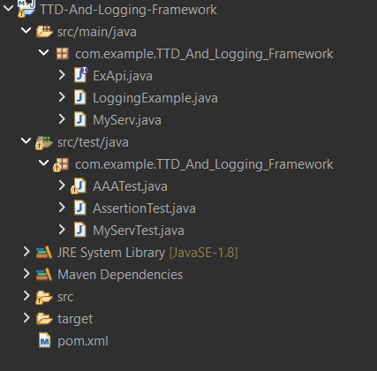
EXERCISE 3:
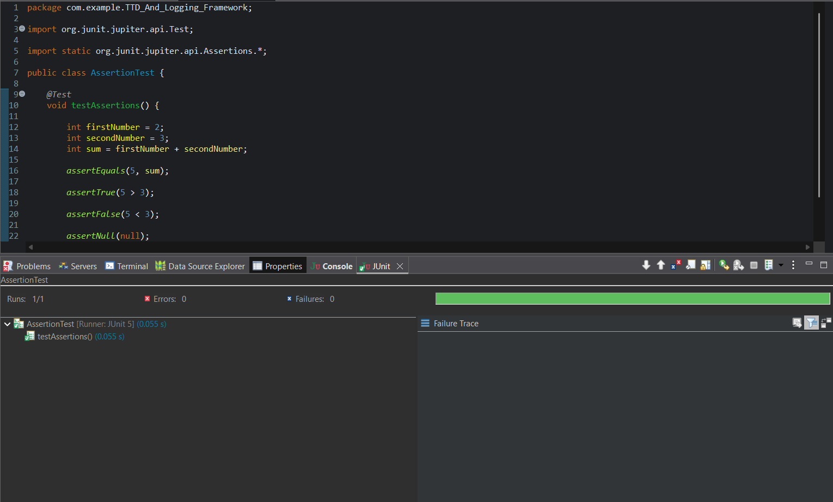

EXERCISE 4:
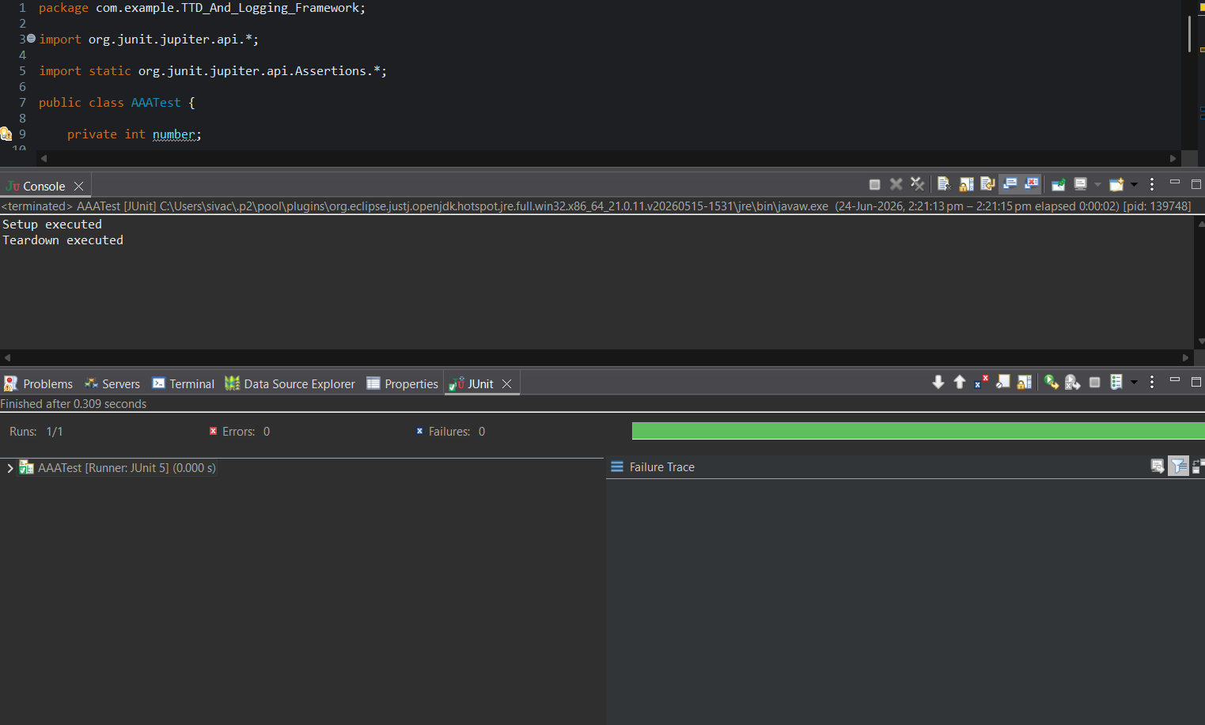

MOCKITO :
EXERCISE 1 AND 2:
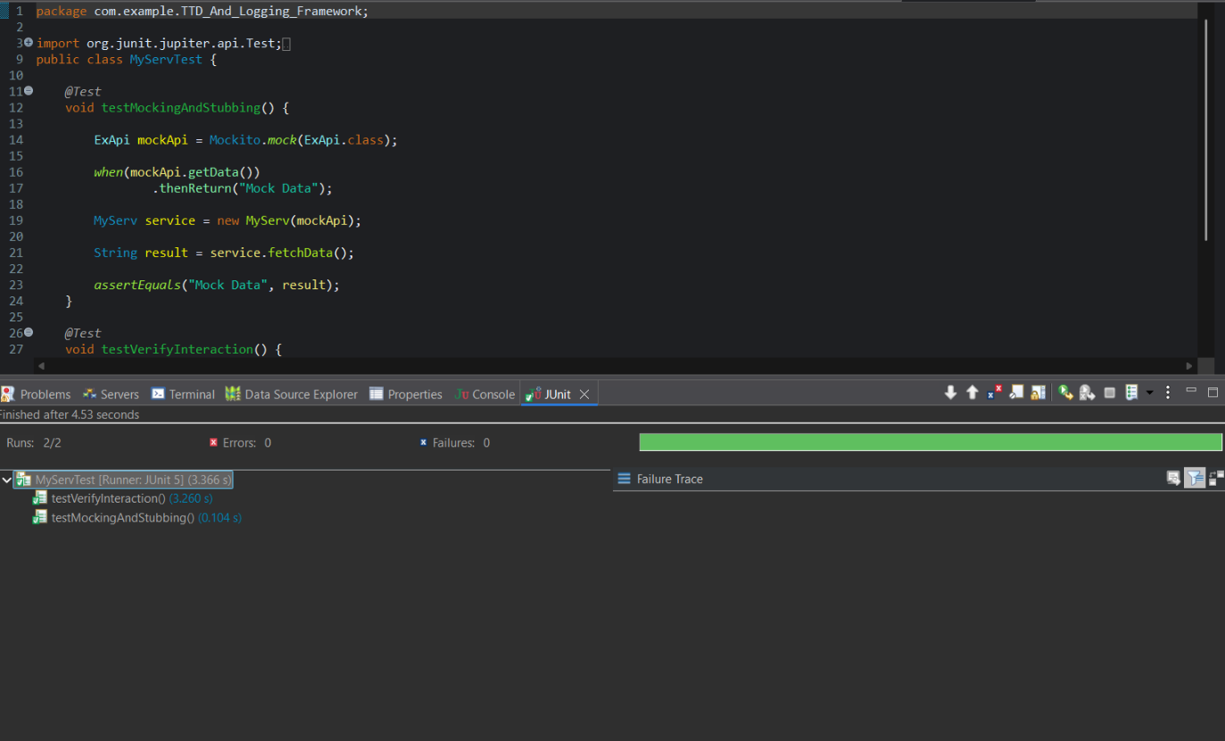

SLF4J LOGGING:
EXERCISE 1:
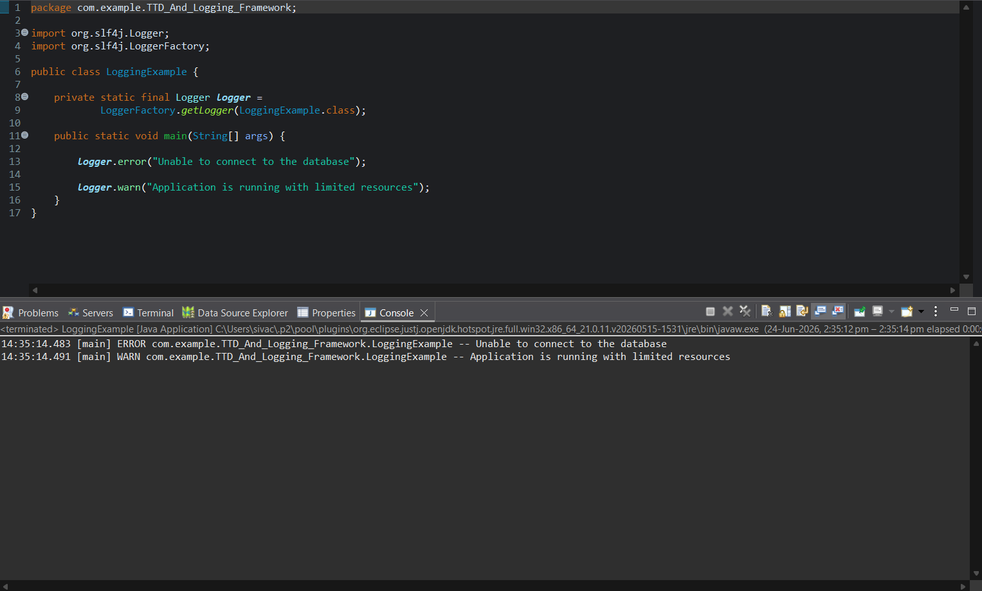

POM.XML :
